• Article • *** 201* Vol.** No.*: ****
doi: 10.1007/s11431-***-****-*

An Accurate Indoor Map Matching Algorithm Based on Activity Detection and Crowdsourced Wi-Fi

YU WenPing, ZHANG JianZhong*, XU JingDong & XU YuWei
College of Computer Science, Nankai University, Tianjin 300350, China
Received ****; accepted ****

Map matching has been widely investigated in indoor pedestrian navigation to improve positioning accuracy and robustness. This paper proposes an accurate map matching algorithm based on activity detection and crowdsourced Wi-Fi (AiFiMatch). Firstly, by taking indoor road segments between activity-related locations as nodes, and the activity type from one road segment to another as directed edge, the indoor floor plan is abstracted as a directed graph. Secondly, the smartphone's motion sensors are utilized to detect different activities based on a decision tree and then the pedestrian's walking trajectory is divided into sub-trajectory sequence according to location-related activities. Finally, the sub-trajectory sequence is matched to the directed graph of indoor floor plan to position the pedestrian by using a Hidden Markov Model (HMM). Simultaneously, Wi-Fi fingerprints are bound to road segments based on timestamp. Through crowdsourcing, a radio map of indoor road segments is constructed. The radio map in turn inversely promotes the HMM based map matching algorithm. AiFiMatch is evaluated by the experiments using smartphones in a teaching building. Experimental results show that the pedestrian can be accurately tracked even without knowing the starting position and AiFiMatch is robust to a certain degree of step length and heading direction errors.
Map Matching, Hidden Markov Model, Activity Detection, Crowdsourced Wi-Fi

Citation: Yu W P, Zhang J Z, Xu J D, et al. An Accurate Indoor Map Matching Algorithm Based on Activity Detection and Crowdsourced Wi-Fi. Sci China Tech Sci, ****, doi: 10.1007/s11431-****

1 Introduction
Location based services have spilled over into all aspects of people's daily life, such as mobile robot localization, pedestrian positioning and vehicle tracking [1-3]. For outdoor users, global positioning system (GPS) has been able to provide a reasonably good positioning accuracy [3]. However, robust and effective indoor pedestrian positioning is still at its infancy due to the blockage of GPS signals.
It is common for indoor positioning schemes to leverage pre-installed infrastructures like Wi-Fi [4], UWB [5], RFID [6], Bluetooth [7], and so on. These systems can offer absolute positioning with a limited error level, but rely on expensive hardware or time-consuming pre-training. Now, motion sensors, including accelerometer, gyroscope and magnetometer, are widely used in smartphones. Therefore, dead reckoning (DR) technique using motion sensors is another way for indoor positioning, which derives the current position by adding the estimated displacement to the previous one [8]. DR technique is known as pedestrian dead reckoning (PDR) for pedestrian tracking and positioning [9-11]. The PDR technique itself can not provide a final solution to the pedestrian positioning problem and another technique is required to provide the starting position estimates.
The positioning errors of PDR technique mainly come from step length and heading direction errors and even minor errors will be magnified by accumulation over time. Indoor maps constrain the allowable motion of a user - people cannot walk through walls. Hence, the fusion of indoor map and PDR is a reasonable solution to provide accurate positioning, namely map matching algorithm [12]. Several map matching algorithms have been proposed to constrain the cumulative errors [11-15]. One of these algorithms uses activity-related locations as virtual landmarks to find the optimal trajectory of a pedestrian. The activity-related locations are special points of a building, such as elevators, stairs and corridor corners. When a pedestrian passes these locations, the pedestrian's activities can be distinguished from normal walking. Human activity detection algorithms based on smartphones have attracted more and more researchers' attention in the past decade. For the symmetry of indoor building structure, activity-based map matching algorithms fail since there may be more than one alternatives for the same activity feature or activity sequence [11].
Crowdsourcing is a low-cost and efficient way to extract useful information from data acquired by crowd participants [16]. The crowdsourcing method has been successfully applied to construct Wi-Fi fingerprint database [17,18]. At present, IEEE 802.11 (Wi-Fi) wireless local networks are widely developed and Wi-Fi signals of access points (APs) are becoming ubiquitous in public buildings, such as office buildings, railway stations and airport terminals. Meanwhile, almost all smartphones are equipped with Wi-Fi interfaces. Hence, it is feasible to introduce Wi-Fi signal feature, such as received signal strength (RSS), into map matching algorithms [19,20] to improve the positioning accuracy. Furthermore, Wi-Fi RSS can be used as a new feature to deal with the multiple hypotheses problem due to the symmetry of indoor building structure.
In this paper, AiFiMatch: a map matching algorithm based on a HMM model is proposed, which integrates activity-based map matching and crowdsourced Wi-Fi. Most of the smartphones can simultaneously collect motion sensors' data and Wi-Fi RSS values. Therefore, these two data are exploited to realize pedestrian positioning in AiFiMatch.
On the one hand, AiFiMatch uses motion sensors' data to detect the pedestrian's location-related activities, divides the pedestrian’s walking trajectory into sub-trajectory sequence according to these location-related activities and matches the sub-trajectory sequence to indoor road map using a HMM model. Thus, AiFiMatch realizes pedestrian positioning based on PDR technique even without knowing the starting position. To the best of our knowledge, there is no paper to use sub-trajectory sequence for indoor pedestrian positioning.
On the other hand, according to map matching results, Wi-Fi RSS values can be bound to physical locations. As time goes by, a Wi-Fi fingerprint database called radio map can be constructed through crowdsourcing. This paper defines the similarity distance between Wi-Fi RSS fingerprint sequences. With the crowdsourced radio map, this similarity distance can be used to reduce the number of candidate states in the HMM model. Thus, AiFiMatch can get the pedestrian's position estimates within a short time delay.

2 AiFiMatch Overview
AiFiMatch is a HMM-based map matching system applied to solve pedestrian positioning problem. The system contains preprocessing module and HMM-based map matching module. The preprocessing module contains three sub-modules including PDR implementation, activity detection and indoor floor plan abstraction. The HMM-based map matching module is composed of two sub-modules: candidate extraction and online Viterbi algorithm.
In this section, an overview of AiFiMatch and its preprocessing module are described. The detail of HMM-based map matching module is given in section 3.

2.1 Architecture Overview
Figure 1 shows the overall architecture of AiFiMatch. The input of the system is indoor floor plans and timestamped sensor data including motion data and Wi-Fi RSS values. The indoor floor plan can be manually entered or generated by indoor map construction algorithms [13]. The motion data and Wi-Fi RSS values are simultaneously collected by utilizing smartphones’ built-in sensors.
AiFiMatch starts with floor plan abstraction module. The input indoor floor plan is abstracted as a directed graph in this module. The PDR implementation module contains walking distance and heading direction estimation. The walking distance and heading direction are estimated based on motion data. The location-related activities are detected with a pre-trained decision tree in activity detection module. Then, according to these location-related activities, the pedestrian's trajectory data including motion data and Wi-Fi RSS values are divided into sub-trajectory sequence.
The directed graph of indoor floor plan and sub-trajectory sequence are passed to the HMM based map matching module whose outputs include the pedestrian position estimates and Wi-Fi fingerprints. These Wi-Fi fingerprints can be used to construct and update indoor radio map. The candidate extraction module selects the candidate road segments from the directed graph of indoor floor plan. This module takes into account the errors of pedestrian heading direction estimates and the previous bound Wi-Fi fingerprints. All selected road segments should satisfy the spatial and Wi-Fi signal conditions. The online Viterbi algorithm module integrates a number of modifications to the standard HMM based map matching algorithm. This module utilizes the sub-trajectory sequence and the detected activities to enhance the map matching accuracy, and implements online Viterbi decoder to determine the most probable indoor road segment sequence efficiently.

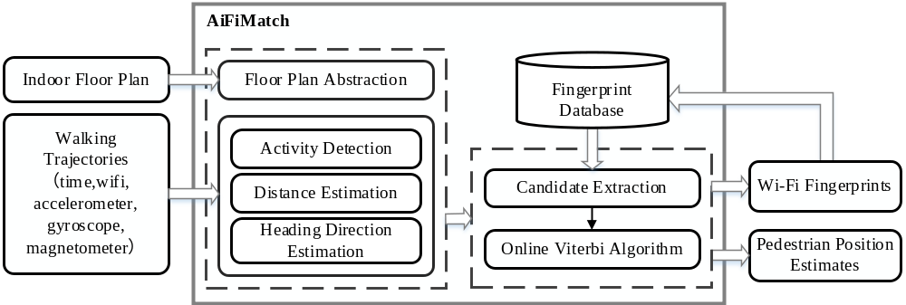
Figure 1 Architecture of AiFiMatch.

2.2 Preprocessing

2.2.1 PDR Implementation
PDR is a positioning scheme that derives the current position by adding the estimated displacement to the previous one based on motion sensors carried by smartphones. In PDR scheme, it is assumed that the heading direction in one step keeps unchanged, and the pedestrian’s position is updated by the steps. Let (x_{k-1}, y_{k-1}) denote the pedestrian's position after k-1 steps, the pedestrian's position after k steps can be expressed as:
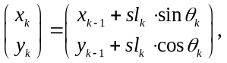 (1)
Where sl_{k} and Ɵ_{k} are the k-th step length and heading direction, respectively. The heading direction is measured by the fusion of gyroscope and magnetometer. The step length and step count estimation approach is out of scope of this paper and can be found in [21].

2.2.2 Activity Detection
In this paper, AiFiMatch considers four types of pedestrian activities: stationary, normal walking, turning at a corner (left or right turn) and turning around (U-turn), which would occur on the flat ground. Each activity corresponds to a specific signal pattern of motion sensors, and all activities can be detected by a decision tree, as shown in Figure 2. The top level separates stationary and walking based on the variance of the accelerometer. The variance of accelerometer is calculated over a sliding window. The size of sliding window is set to 0.6 s and the threshold of variance of accelerometer is set to 0.25 in this paper. Based on the rotation rate from the gyroscope, the normal walking and turns are separated in the second level. Turns are detected using the peak detection algorithm [11] and the threshold is set to 1.05 rad/s. The third level separates the U-turn from the normal turn (left or right turn) based on the rotation angle during the turning. The threshold for distinguishing between U-turn and normal turn is set to 135°.
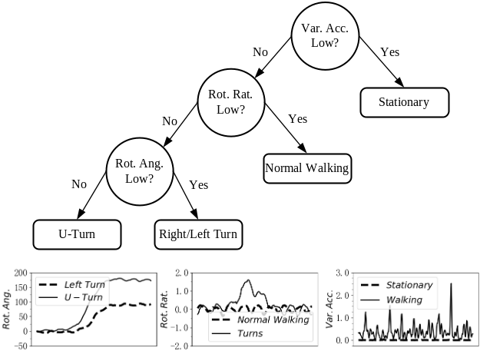
Figure 2 Decision tree for activity detection.
In order to evaluate the decision tree for activity detection in this paper, a pilot experiment is conducted. Three participants with different brands of smartphones are asked to complete three activities (U-turn, left and right turn) in this experiment. The sample size of each activity is 60 traces. The activity detection result is summarized in Table 1.
Table 1 Confusion matrix of activity detection
Activity Type | Left Turn | Right Turn | U-turn | No Type
Left Turn | 58 | 0 | 0 | 2
Right Turn | 0 | 59 | 0 | 1
U-turn | 0 | 0 | 60 | 0

2.2.3 Indoor Floor Plan Abstraction
In the indoor environment, there are many activity-related locations, such as corridor corners and entrances of rooms, where pedestrians may perform different activities other than normal walking. These special locations divide the indoor roads into road segments. These road segments are defined as nodes in the form of (coordinate of first endpoint (x₁, y₁), accessible direction of first endpoint (φ₁), coordinate of second endpoint (x₂, y₂), accessible direction of second endpoint (φ₂)), and the activity type from one road segment to another is defined as directed edge in the form of (Activity Type (AT)). Therefore, the indoor floor plan can be represented as a direction graph. Figure 3 shows an example of indoor floor abstraction.

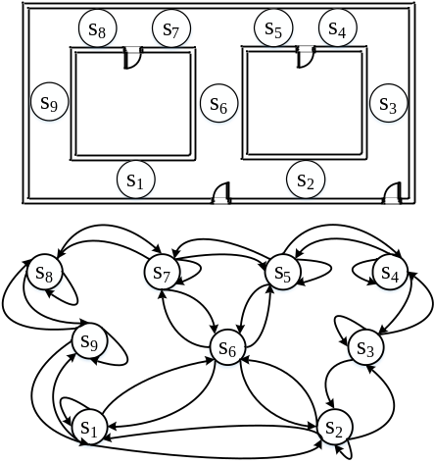
Figure 3 An example of floor plan abstraction.

3 HMM based Map Matching Algorithm

3.1 Hidden Markov Model
Taking computing power and energy limit of a smartphone into account, a HMM based map matching algorithm is introduced to match the pedestrian's sub-trajectory sequence to the directed graph of indoor floor plan. The HMM can be represented as 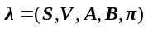, where:
(1) 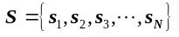 is the set of possible states and 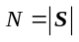. In this case, each state represents an indoor road segment, that is, a node of the directed graph. Therefore, a state s is represented as the ordered tuple in the form of (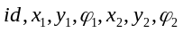), where id is the identification of road segment, and , , , , 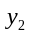 and 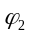 are different attributes of node of the directed graph, respectively. The length of road segment and can be obtained from the coordinates of two endpoints of this road segment. Note that two or more road segments connected by a straight line can form new states (Figure 4).
(2) 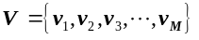is the set of observations and 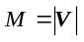. For each walking trajectory of a pedestrian, PDR technique gives displacement distance and heading direction estimates. However, due to the effect of many metal materials on the magnetic field in buildings, the heading direction errors can be quite large. Therefore, in this case, the estimate of displacement distance (dist) is taken as observation in the HMM.
(3) 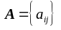is the state transition probability distribution, where 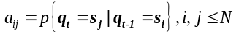, and denotes the state at time t. In this case, the transition probability 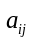 is the probability of walking from the previous road segment 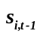 to the current road segment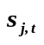. Intuitively, for probable transition between two road segments, the pedestrian's activity should match the activity type between the same two segments. Therefore, given the detected activity of a pedestrian 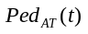 at time t and the activity type between two segments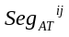, this intuition can be modeled as:
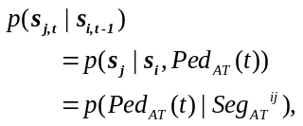 (2)
Where 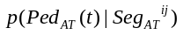 can be found in confusion matrix.
(4) 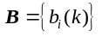is the observation probability distribution in each state, where and is the observation at time t. The observation probability, also called emission probability, represents the likelihood of observing a certain measurement resulted from a given state. In this case, given a displacement distance observation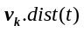, there is an emission probability 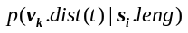 for each candidate road segment. Here, 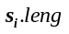 is the length of road segment . If a pedestrian has passed the whole road segment, AiFiMatch models the emission probability as a Gaussian distribution:
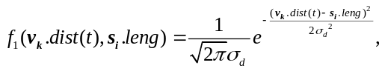 (3)
Where 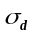 is the standard deviation of the measured displacement distance. Based on the distance calculation method of PDR, the displacement distance is proportional to step length. Therefore, can be obtained based on the standard deviation of step length 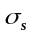. Considering the situation that a pedestrian is walking on the road segment, all long enough candidate road segments should have the same probability, and AiFiMatch models the situation as:
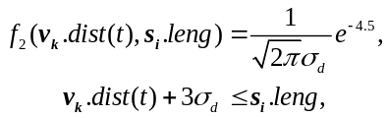 (4)
Hence, the final emission probability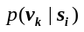can be expressed as:
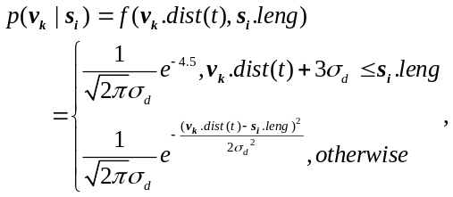 (5)
(5) 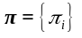is the initial state distribution, where 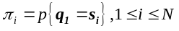. If the starting position or the first road segment is known, the initial state distribution is 1 since the first road segment is the only candidate. Otherwise, all candidate road segments are selected by the candidate extraction module and their initial state distributions are uniform. When the pedestrian moves a step, the initial state distributions of all candidates are re-estimated by the following equation.
(6)
Where 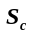 is the set of all candidates. The initial state distributions keep updating until the pedestrian’s first location-related activity is detected. All the possible states at next time in the HMM model can be derived according to the connectivity in the directed graph of indoor floor plan.

3.2 Candidate Extraction
AiFiMatch uses the heading direction of a pedestrian and Wi-Fi fingerprint to select the candidate states. Here, the extraction algorithm by heading direction is described and the Wi-Fi fingerprint extraction algorithm is discussed in the next subsection.
Intuitively, the heading direction of a pedestrian should match the direction of road segment. Therefore, AiFiMatch models the direction difference by the following function to select the candidates:
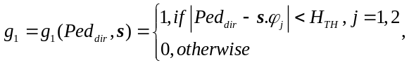 (7)
where 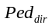 denotes the heading direction of a pedestrian, s is a state, and 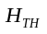is the threshold for candidate extraction, which is set to 55° based on the experiments.

3.3 Wi-Fi Enhancement
An indoor map can be viewed as an important spatial information source which provides constraints. Therefore, map matching algorithm is an excellent way to improve the positioning accuracy, especially in narrow corridors. But it also has some limitations when the indoor building structure exists symmetries. Supposing that a pedestrian walks along the segment sequence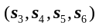, as shown in Figure 4. For the given observable states, it can be seen that the segment sequence 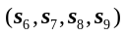 may have almost the same matching probability as the actual one. This is known as multiple hypotheses problem. In this situation, the traditional HMM based map matching algorithm fails [11].
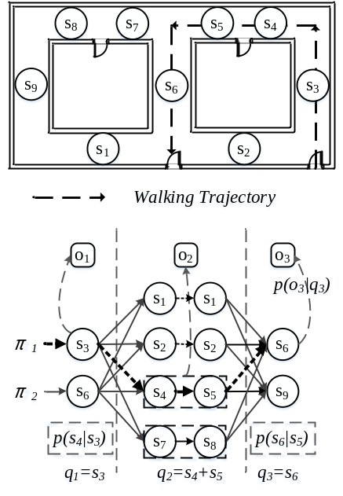
Figure 4 An example of the multiple hypotheses problem and illustration of the Viterbi decoding.
The most probable road segment sequence for a pedestrian's walking trajectory is determined by the online Viterbi algorithm [12]. Then, for each of the determined road segments, with its one endpoint as the starting position, the pedestrian's positions can be derived by PDR. Therefore, simultaneously collected Wi-Fi fingerprints during walking can be bound to the corresponding positions by timestamp alignment, and then the Wi-Fi fingerprint database of indoor environment is updated through crowdsourcing. In order to improve the HMM based map matching algorithm described above, in this paper, the Wi-Fi fingerprints are bound to not only physical positions but also road segments. All Wi-Fi fingerprints of one road segment are sorted in the road segment's direction.
Wi-Fi similarity distance is introduced to distinguish the real road segment sequence from multiple hypotheses due to the symmetry of building structure. For two fingerprints f_{x} and f_{y}, and MAC address set of access points X and Y, the similarity distance 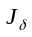 between f_{x} and f_{y} can be defined as:
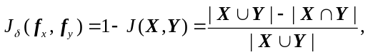 (8)
Equation (8) is known as Jaccard distance. With this similarity distance , the similarity function 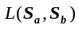 between two fingerprint sequences 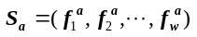 and 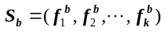 is defined as:
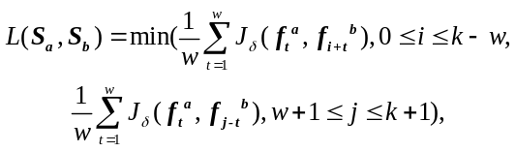 (9)
Where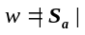, 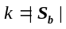 and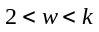. The smaller the value of is, the higher the similarity between 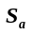and 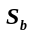 is. Given candidate road segment set G and the set R of all road segments bound with Wi-Fi fingerprint sequence, AiFiMatch models the similarity distance of two Wi-Fi fingerprint sequences and the different stages of fingerprint database by the following function to select the candidates:
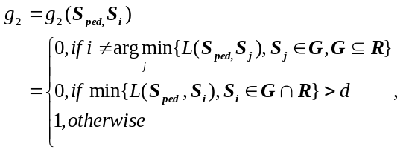 (10)
Where d is the threshold to distinguish between two Wi-Fi fingerprint sequences.

3.4 Optimal State Sequence Estimation
Once the HMM parameters are estimated, for a given observation sequence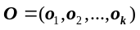, the Viterbi algorithm can be used to get the most probable state sequence 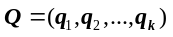. The Viterbi algorithm is implemented using dynamic programming. In order to represent that the HMM model reaches the state along a certain path at time t and outputs the maximum probability, a Viterbi variable 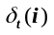 is defined as:
(11)
At time t+1, the maximum probability to reach the state can be recursively derived from the Viterbi variable at time t by the following equation.
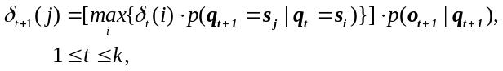 (12)
For the real-time operation of AiFiMatch, it cannot wait until the whole observation sequence is available. Hence, Viterbi algorithm in an incremental manner is used in AiFiMatch. Every time a new activity of the pedestrian is detected, and then the HMM parameters are calculated for the new introduced sensors data and associated candidate states. Figure 4 illustrates the Viterbi decoding process in the HMM model. In Figure 4, the thick dashed lines are the decoded sequence.
During the beginning process of the algorithm, if the number of states is too small, the most probable state sequence is not always the correct one, especially when the starting position of the pedestrian is unknown. Therefore, a criterion 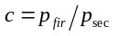to determine the status of this algorithm is given, where 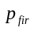 and 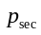 are the highest and second highest probability of the state sequences, respectively. A threshold is set and the Viterbi decoding result is chosen if c is greater than or equal to the threshold. The selected state sequence represents the pedestrian's traveled road segments.
AiFiMatch algorithm is summarized with the pseudocode in Algorithm 1 (See Appendix A).

4 Evaluation

4.1 Environment Setup
The performance of AiFiMatch in real world environment is evaluated by experiments conducted in the fifth floor of a teaching hall on Nankai university campus. The experimental area approximately covers a 78.95m × 56.40m floor plan, as shown in Figure 5. A prototype is implemented and installed in a 360 N5 Android version 6.0.1 smartphone, an OPPO R827T Android version 4.4.0 smartphone and a Xiaomi 3W Android version 6.0.1 smartphone. The prototype samples the accelerometer, gyroscope and magnetometer sensors at 50Hz and Wi-Fi at 1Hz. In the experiments, three participants (two males and one female) are asked to walk along Trajectory No.1 (T₁), Trajectory No.2 (T₂) and Trajectory No.3 (T₃) at constant speed. In order to record the walking trajectories, all participants' shoes are painted with colored powder. This offers the ground truth.
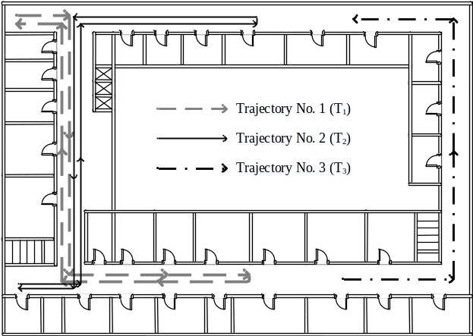
Figure 5 Environment floor plan and ground truth of trajectories.

4.2 Similarity Distance between Fingerprint Sequences
A pilot experiment is conducted to evaluate the similarity distances between two fingerprint sequences of same and different road segments. Each participant walks along two symmetric road segments in two directions. The participant with 360 N5 smartphone is asked to repeat 12 times while the others repeat 6 times. Among them, half of the Wi-Fi data collected by 360 N5 smartphone are randomly taken to construct Wi-Fi fingerprint database, while other Wi-Fi data are used as online Wi-Fi fingerprint sequences.
The maximum similarity distances between fingerprint sequences of same road segments and the minimum similarity distances between fingerprint sequences of different road segments are shown in Figure 6. With the increase of the length of Wi-Fi fingerprint sequence w, the similarity distances between two sequences of same segments gradually decreases, while the similarity distances between two sequences of different segments gradually increases. Considering the device diversity, in order to avoid the missing of correct alternative segments, the minimum value of the threshold d should be greater than 0.773. In the subsequent positioning performance experiments, the threshold d is set to 0.78.
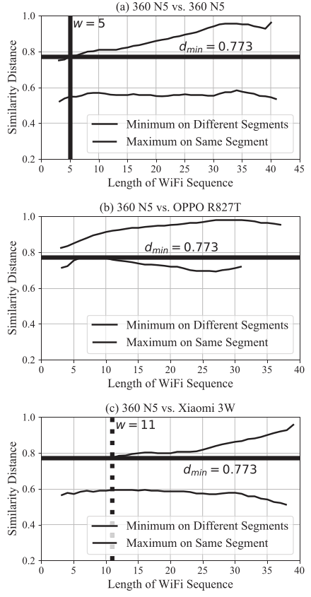
Figure 6 Similarity distances between two Wi-Fi fingerprint sequences from three brands of smartphones.

4.3 Performance of Map Matching
The environment setup for the experiments to evaluate the positioning performance of AiFiMatch has been given in section 4.1. To obtain accurate experimental results, all participants repeat each of the three trajectory shown in section 4.1 six times. First, the online positioning performance comparison between AiFiMatch and basic PDR is shown. Furthermore, the effect of step length and heading direction errors on positioning accuracy are analyzed, and the convergence performance is also discussed. At last, the offline positioning results are given.

4.3.1 Online Positioning Performance
Euclidean distance between the estimated position and the ground truth is introduced to indicate positioning accuracy. Figure 7 shows the online positioning results of all trajectories for basic PDR with a known starting position and AiFiMatch without knowing the starting position. Here, the mean position of all segment candidates' starting positions is taken as the starting position of AiFiMatch. Therefore, the positioning errors of AiFiMatch are quite large at the initial stage. After passing a number of steps, the traveled segment sequence is determined by AiFiMatch even without knowing the starting position, and the positioning errors of AiFiMatch drop rapidly. Generally, for one trajectory, the greater the traveled distance is, the larger the positioning errors of basic PDR due to cumulative errors are, and Figure 7 shows the trend. However, the cumulative errors have been successfully constrained by AiFiMatch, and the positioning errors of AiFiMatch are not more than 4.9 m.
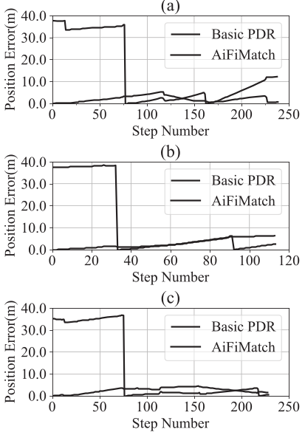
Figure 7 Online positioning results for each trajectory. (a) T₁. (b) T₂. (c) T₃.

4.3.2 Effect of Step Length and Heading Direction Errors
The major errors of PDR techniques are mainly from step length and heading direction errors. Therefore, the effect of step length and heading direction errors on the average online positioning errors are analyzed. Both of them are supposed to follow the Gaussian distributions with zero mean. Let and denote the standard deviation of step length estimates and the standard deviation of heading direction estimates, respectively. When changes from 0.1 m to 0.5 m, 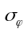 is set to 10°. When changes from 10° to 50°, is set to 0.1 m. Figure 8 shows the positioning errors of all trajectories with different step length and heading direction errors. The performance of AiFiMatch in all error cases is superior to the basic PDR technique. From Figure 8, one may see that the average online positioning errors increase gradually with the increase of step length error or heading direction errors. T₁ and T₃ have five location-related activities while T₂ has only two. As a result, given the same heading direction errors, AiFiMatch is more robust in the online positioning performance for T₁ and T₃ than T₂, which can also be seen from Figure 8 (d-f).
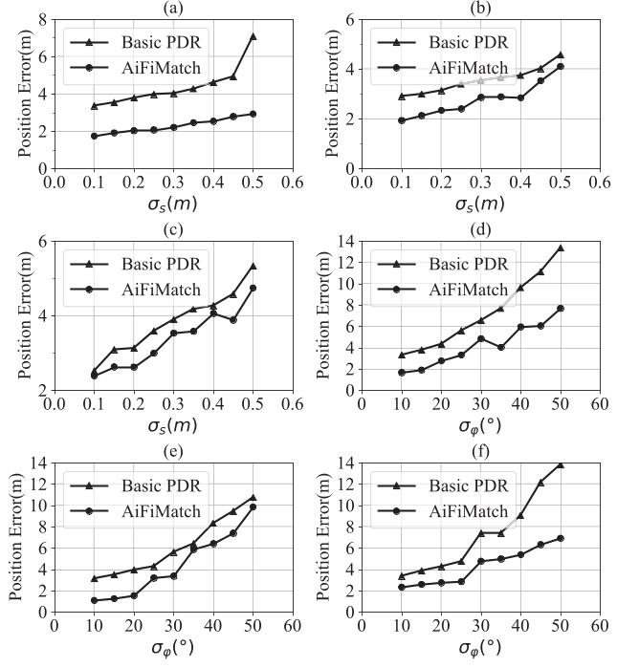
Figure 8 Online positioning errors for each trajectory with given standard deviations of step length and heading direction. (a) T₁. (b) T₂. (c) T₃. (d) T₁. (e) T₂. (f) T₃.

4.3.3 Convergence Speed
The traveled distance before converging to a unique state sequence reflects the convergence speed of a map matching algorithm. The greater the traveled distance is, the slower the convergence speed is. Here, the convergence speed of AiFiMatch algorithm is compared with the convergence speed of the map matching algorithm proposed by Zhou et al [11]. Figure 9 shows the traveled distance before convergence of the algorithm proposed by Zhou et al, AiFiMatch without Wi-Fi enhancement and AiFiMatch with Wi-Fi enhancement. At the initial stage, fingerprint database is empty (T₁), and both AiFiMatch and the algorithm proposed by Zhou et al successfully converge even without knowing the starting position. AiFiMatch without Wi-Fi enhancement and the map matching algorithm proposed by Zhou et al fail to converge ( means that T₂ cannot be converged.) due to the symmetry of indoor building structure. However, with Wi-Fi enhancement, T₂ has a fast convergence, and in most cases, such as T₂ and T₃, the traveled distance is much shorter than that without Wi-Fi enhancement.
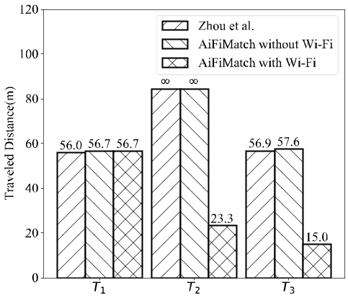
Figure 9 Traveled distance before convergence for each trajectory.

4.3.4 Offline Positioning Performance
The offline positioning results are derived retrospectively after matching the walking trajectory of a pedestrian to a unique road segments sequence by AiFiMatch. Figure 10 shows the tracking trajectories and Table 2 gives the offline positioning performance for three trajectories. The mean error of the offline positioning for tree trajectories is about 1.24 m, which indicates that AiFiMatch can track pedestrians' trajectories accurately in the experimental environment.
Table 2 Offline positioning performance for three trajectories
Trajectory  No. | Length  (m) | Mean  Error(m) | Step  Num. | Detected  Step
1 | 176.1 | 1.09 | 238 | 240
2 | 84.6 | 1.65 | 114 | 114
3 | 175.9 | 1.19 | 228 | 227

5 Conclusion
This paper proposes a HMM based map matching Algorithm, AiFiMatch, to realize indoor pedestrian positioning. The HMM model is used to match walking sub-trajectory sequence to road segments sequence. The architecture of AiFiMatch is investigated and its different modules are designed. The performance of AiFiMatch has been evaluated by experiments in a teaching building. The results show that AiFiMatch can track pedestrian's trajectory accurately even without knowing the starting position and it is also robust to a certain degree of step length and heading direction errors. The mean offline positioning error is about 1.24 m. In addition, AiFiMatch can also construct and update fingerprint database based on road segment through crowdsourcing. With the crowdsourced Wi-Fi fingerprint database, AiFiMatch has a fast convergence speed and can effectively solve the multiple hypotheses caused by the symmetry of indoor building structure.
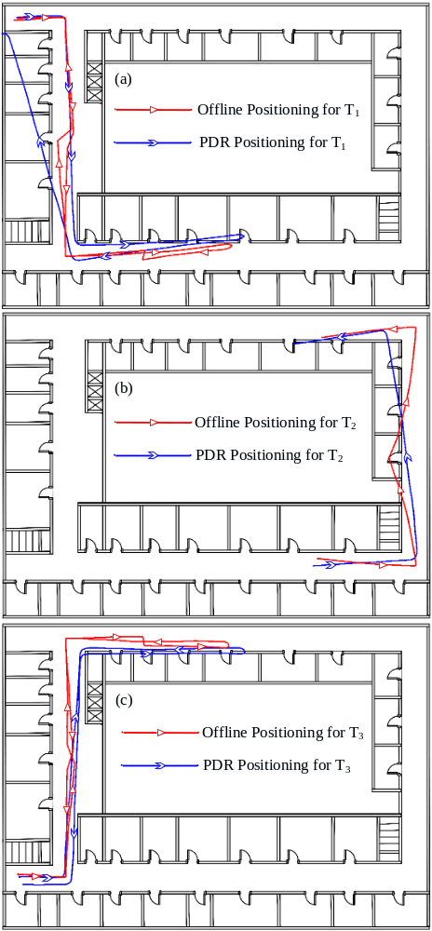
Figure 10 (Color online) Offline positioning results for each trajectory. (a) T₁. (b) T₂. (c) T₃.
This work was supported by the National Natural Science Foundation of China (No. 61702288), the Natural Science Foundation of Tianjin in China (No. 16JCQNJC00700) and the Fundamental Research Funds for the Central Universities.
- Wu J, Wang J S, Wang L P, Li T M. Dynamics and control of a planar 3-DOF parallel manipulator with actuation redundancy. Mechanism and Machine Theory, 2009, 44(4): 835-849
- Wu J, Yu G, Gao Y, Wang L P. Mechatronics modeling and vibration analysis of a 2-DOF parallel manipulator in a 5-DOF hybrid machine tool. Mechanism and Machine Theory, 2018, 121, 430-445
- Zampella F, Ruiz A R J, Granja F S. Indoor positioning using efficient map matching, RSS measurements, and an improved motion model. IEEE Transactions on Vehicular Technology, 2015, 64(4): 1304-1317
- Bahl P, Padmanabhan V N, Balachandran A. Enhancements to the RADAR user location and tracking system. Microsoft Research, 2000, 2(MSR-TR-2000-12): 775-784
- Fontana R J, Gunderson S J. Ultra-wideband precision asset location system. In: Proceedings of the 2002 IEEE Conference on Ultra Wideband Systems and Technologies. Digest of Papers. IEEE, 2002: 147-150
- Ni L M, Liu Y, Lau Y C, et al. LANDMARC: indoor location sensing using active RFID. Wireless networks, 2004, 10(6): 701-71
- Zafari F, Papapanagiotou I. Enhancing ibeacon based micro-location with particle filtering. In: 2015 IEEE Global Communications Conference (GLOBECOM). IEEE, 2015: 1-7
- Wu J, Wang D, Wang L P. A control strategy of a two de-grees-of-freedom heavy duty parallel manipulator. Journal of Dynamic Systems, Measurement and Control, 2015, 137(6): 061007-1-10
- Fu N, Zhang J, Yu W, et al. Crowdsourcing-based wifi fingerprint update for indoor localization. in: Proceedings of the ACM Turing 50th Celebration Conference-China. ACM, 2017: 34
- Alaoui F T, Renaudin V, Betaille D. Points of interest detection for map-aided PDR in combined outdoor-indoor spaces. In: Proceedings of the 2017 International Conference on Indoor Positioning and Indoor Navigation (IPIN). IEEE, 2017: 1-8
- Zhou B, Li Q, Mao Q, et al. Activity sequence-based indoor pedestrian localization using smartphones. IEEE Transactions on Human-Machine Systems, 2015, 45(5): 562-574
- Aly H, Youssef M. semMatch: Road semantics-based accurate map matching for challenging positioning data. In: Proceedings of the 23rd SIGSPATIAL International Conference on Advances in Geographic Information Systems. ACM, 2015: 5
- Zhou B, Li Q, Mao Q, et al. ALIMC: Activity landmark-based indoor mapping via crowdsourcing. IEEE Transactions on Intelligent Transportation Systems, 2015, 16(5): 2774-2785
- Abdelnasser H, Mohamed R, Elgohary A, et al. SemanticSLAM: Using environment landmarks for unsupervised indoor localization. IEEE Transactions on Mobile Computing, 2016, 15(7): 1770-1782
- Qiu C, Mutka M W. iframe: Dynamic indoor map construction through automatic mobile sensing. Pervasive and Mobile Computing, 2017, 38: 346-362
- Wang B, Chen Q, Yang L T, et al. Indoor smartphone localization via fingerprint crowdsourcing: Challenges and approaches. IEEE Wireless Communications, 2016, 23(3): 82-89
- Zhang X, Yang Z, Wu C, et al. Robust trajectory estimation for crowdsourcing-based mobile applications. IEEE Transactions on Parallel and Distributed Systems, 2014, 25(7): 1876-1885
- Xiang L, Tai T Y, Li B, et al. Tack: Learning Towards Contextual and Ephemeral Indoor Localization With Crowdsourcing. IEEE Journal on Selected Areas in Communications, 2017, 35(4): 863-879
- Newson P, Krumm J. Hidden Markov map matching through noise and sparseness. In: Proceedings of the 17th ACM SIGSPATIAL international conference on advances in geographic information systems. ACM, 2009: 336-343
- Seitz J, Jahn J, Boronat J G, et al. A hidden markov model for urban navigation based on fingerprinting and pedestrian dead reckoning. In: 2010 13th Conference on Information Fusion (FUSION). IEEE, 2010: 1-8
- Woodman O, Harle R. Pedestrian localisation for indoor environments. In: Proceedings of the 10th international conference on Ubiquitous computing. ACM, 2008: 114-123

Appendix A

